Create a Shortcut to Educator’s Handbook
on your Desktop

- Click the “Redwood Weblinks” icon on the Launchpad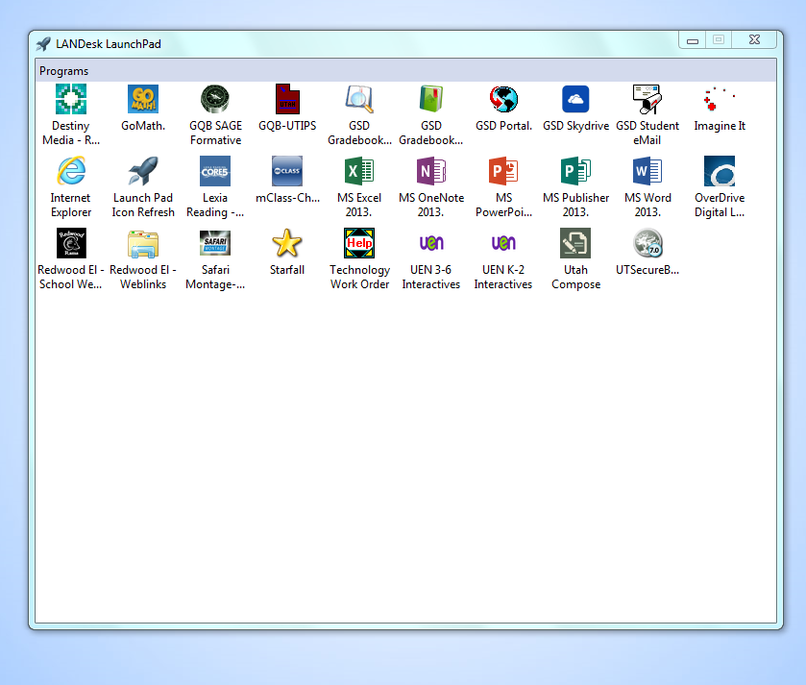
- Find “Educator’s Handbook.” Clicking on “Educator’s Handbook” will take you to the log in page for that site.
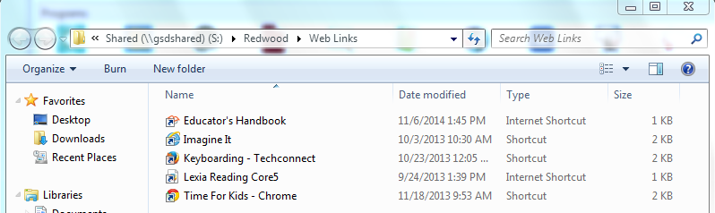

- If you would like to make a link on your desktop to Educator’s Handbook:
  - Click the little book icon
  - Drag the icon to your desktop.
  - When you let go of the mouse button, the little book icon for Educator’s Handbook will appear on your desktop.
