If a teacher forgets the password they set for a GoMath Assessment (Dee Rigdon)

Log into ThinkCentral
Click on Assignments on the Assignment Gadget
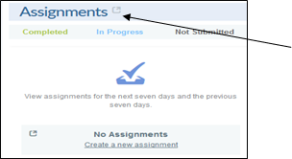
There she will see the assignments and tests that have been assigned to the students. Note: If the assignment is not displayed on the screen, open the window(s) larger under Find Assignment and click Find.
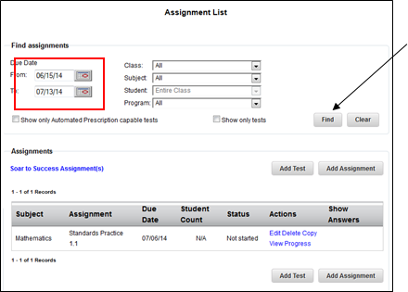
Find the Progress Monitoring Test

Click on Edit under the Actions Column
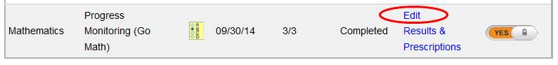

Scroll down and you will be able to see the password you created for this test.

If you scroll down on this page you will see the password that was originally created for this test.
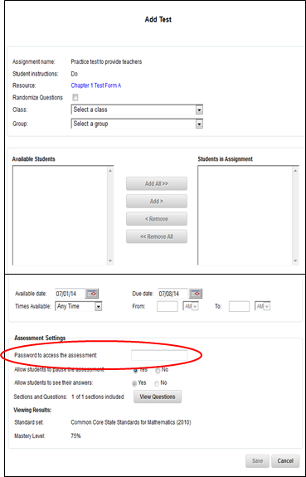

Adding Students to Existing GoMath Rosters (Brenda Hale - Email 9/9/14)
Many of you (and your teachers) were also wondering how to add students to existing GoMath rosters. Here's a four step image to help. Click on classes, manage, click on the radio button next to the specific class, click edit class. The next page is where I was confused, it looks like you can only change assignments and then assign those to students in the class. However, if you click assign students you'll be taken to a screen where you can add students to the roster.
