Gradebook: Are your grades posted?
Here is how you can check.
Log into Gradebook, and choose reports.
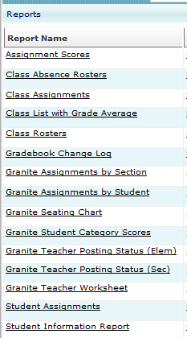
Click “Granite Teaching Posting Status” (Elem)

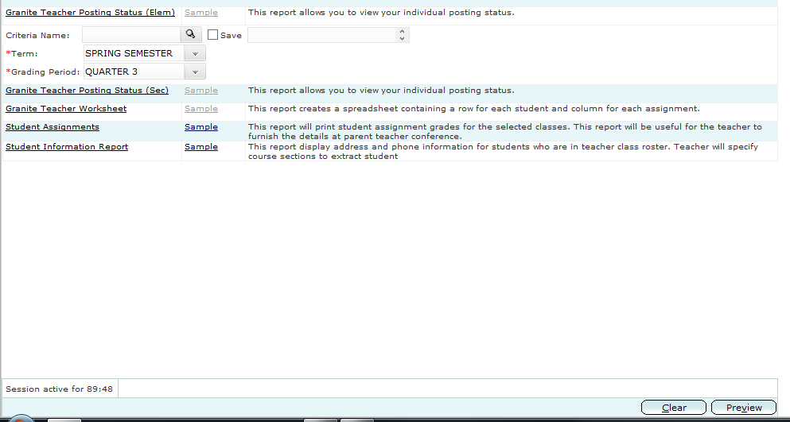
Click ”Preview”

This opens a new screen. If all is green, you are good. If not, fix things and check again.

