Logging In Students for Hour Of Code
- You will need the student login cards. To print them, sign in to your account. Click on “Students and Progress.” Then click on “Manage Students.” At the bottom of the page you will see a place to print the login cards. 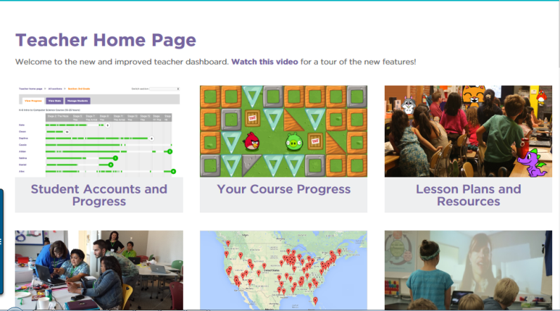
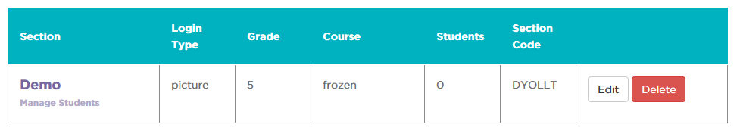
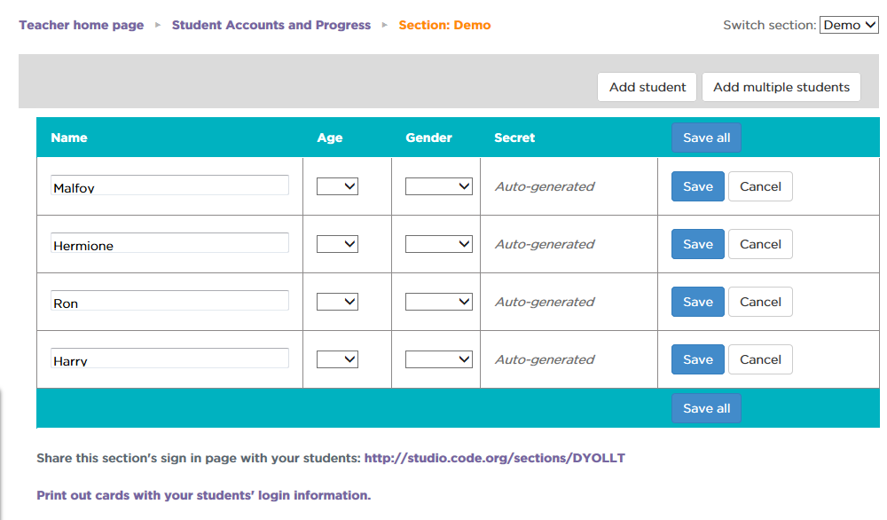
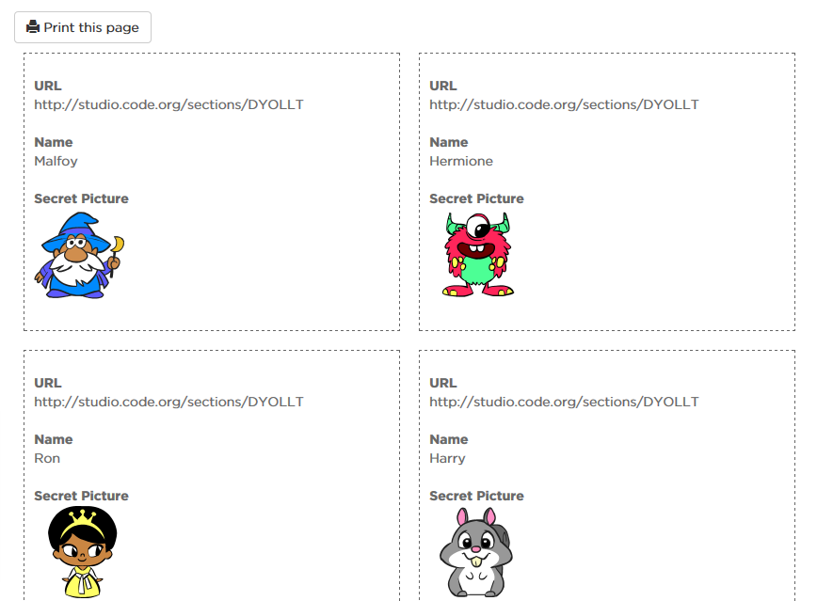
- Have students go to the unique URL that was generated for your class. It is in the same place as the login cards.
- Students will click on their name. 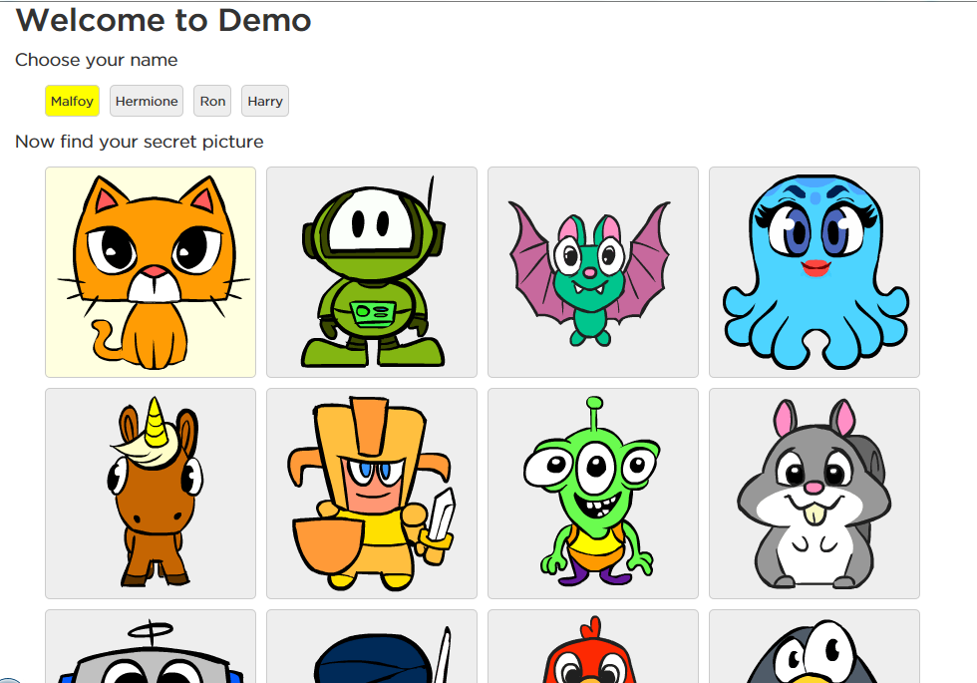
- Then choose their login picture. And click “Sign In” at the bottom of the screen. 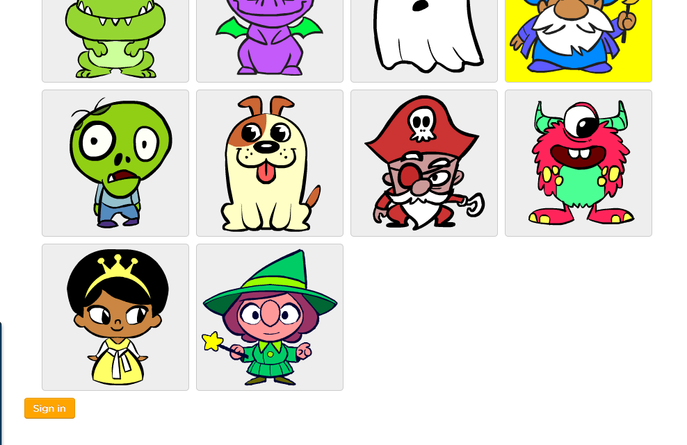
- The first time they login it will ask them their age. For more info on Code.org’s student privacy policy, click here. They won’t be able to login without choosing their age. 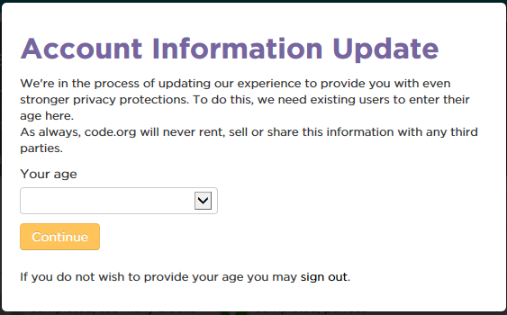
- It will then show what they are working on. Students will click “Try Now” or “Continue”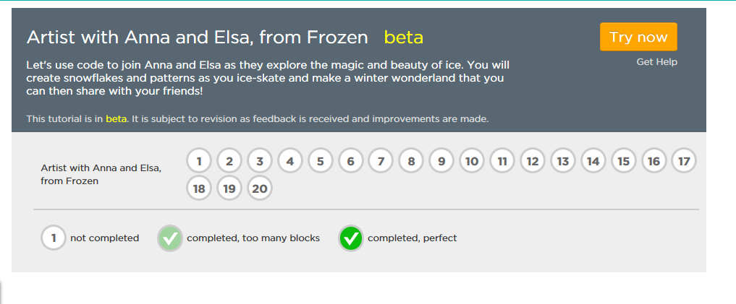
- If students finish their Hour of Code early, they can click on their name and choose “My Progress.”
- It will then show other courses that they can try. 