Setting Up a Class on Code.org
- Create an account for yourself. Go to code.org and click on “Sign In” in the top right hand corner. 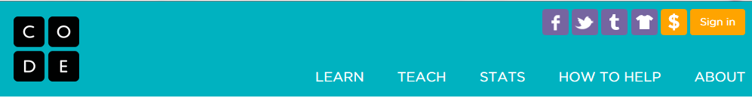
- Click on “Sign Up.” 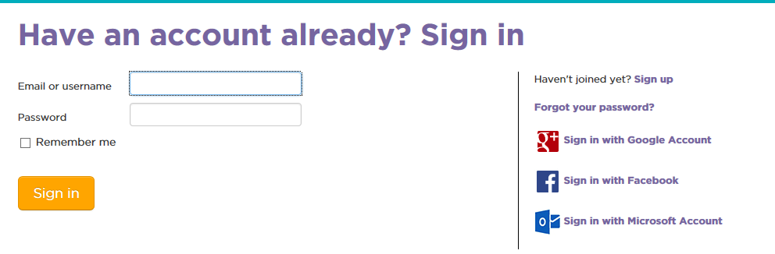
- Choose “Teacher Sign Up.”
- Fill out the form with your information.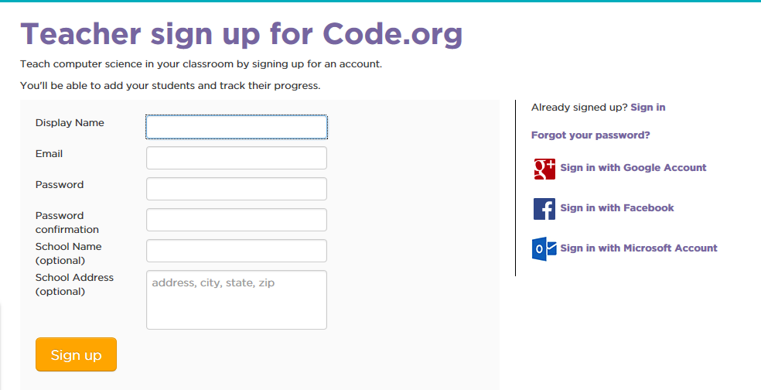
- Once you have created an account it will take you to the Teacher Home Page. Click on “Student Accounts and Progress.”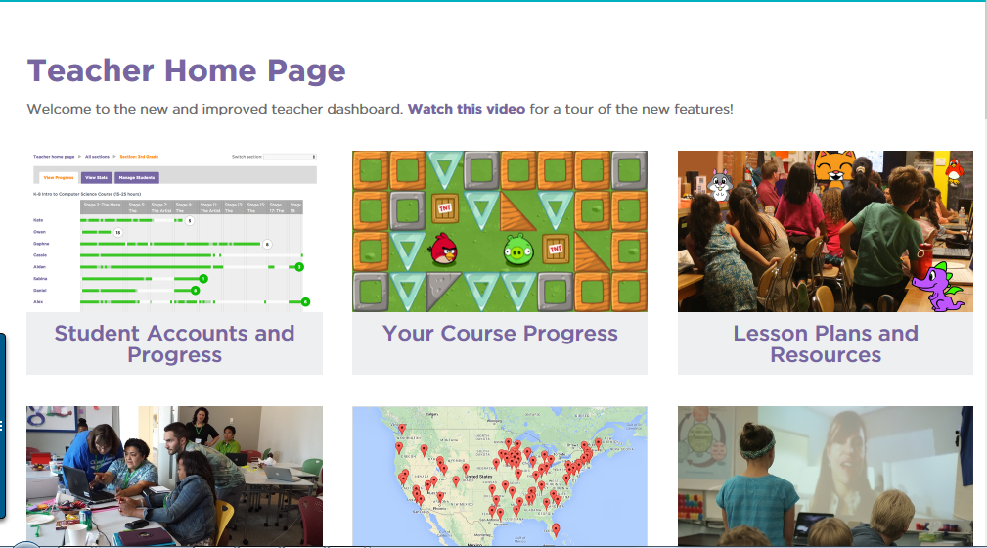
- Choose “New Section.”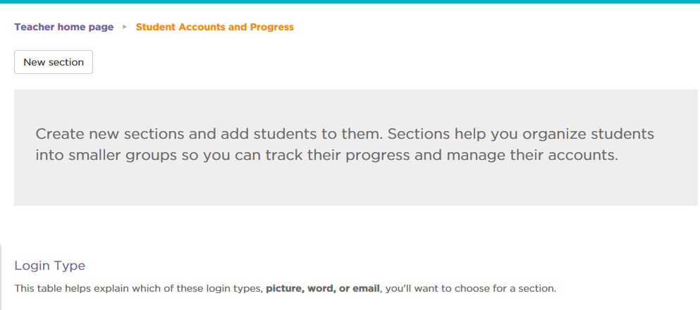
- Give the class a name, login type (I would suggest picture even for upper grades), grade, and course (I would suggest HourOfCode or the new Frozen tutorial). 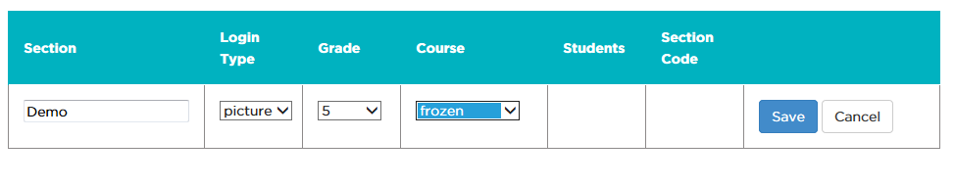
- When you click on “Save” it will give you a section code and the ability to manage students. 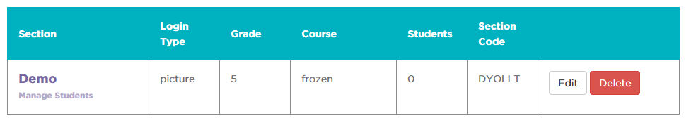
- Click on “Manage Students”
- Click on “Add Multiple Students.”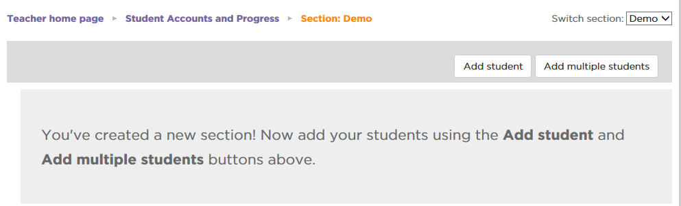
- Type the names of your students in the box. You will have a unique URL for your class so you can just put first names if you want. Click on “Done” when you have entered all the names.
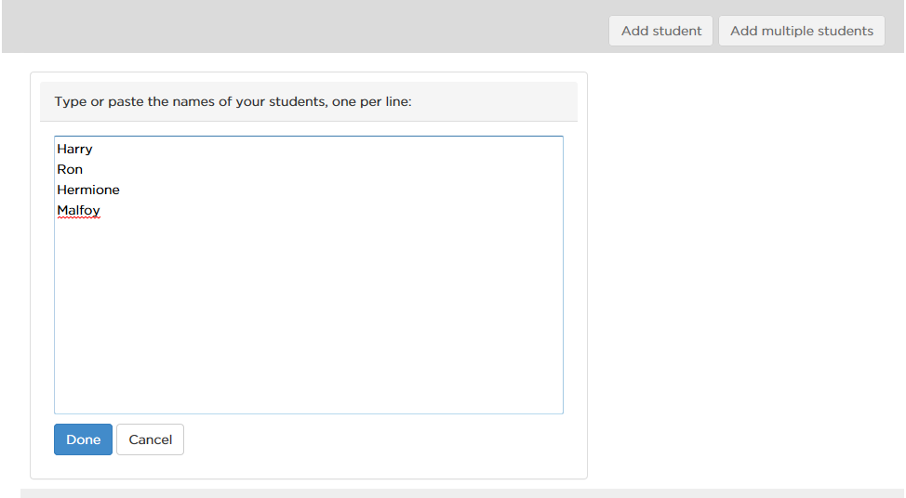
- Then click on “Save All.” You can choose to fill in the ages and genders of your students but it is not required.
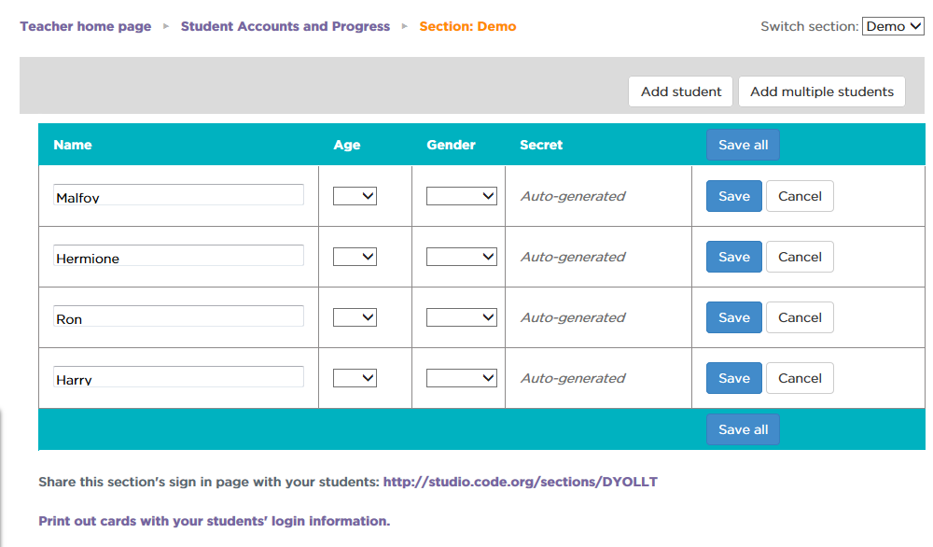
- Your class is now set up. At the bottom of the screen you will see the unique URL for your class and a link to print login cards. 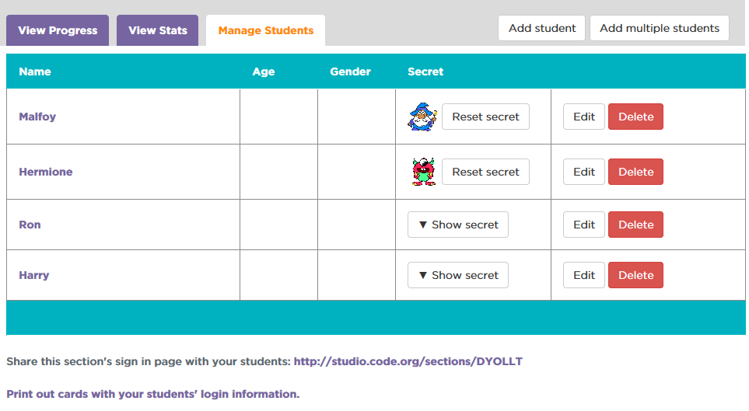
- You can check the progress of your students by clicking on View Progress.