Submitting a Technology Work Order

- Click on the Technology Work Order icon on the Launchpad (You can also reach Technology Work Order through the “Quick Links” on the GSD Employee Intranet)
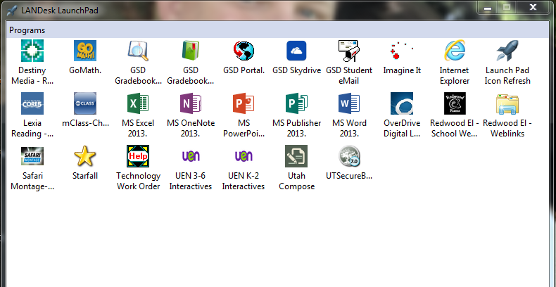
- Log in with your GSD Username and Password
- Click “Submit New Case”
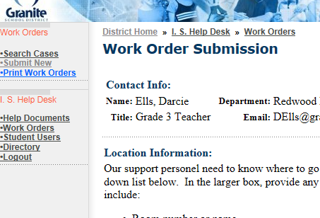

- Enter Location Information – Make sure the Location Box shows “Redwood-342” selected. Add other location and contact info if you’d like. The more specific you are, the better.
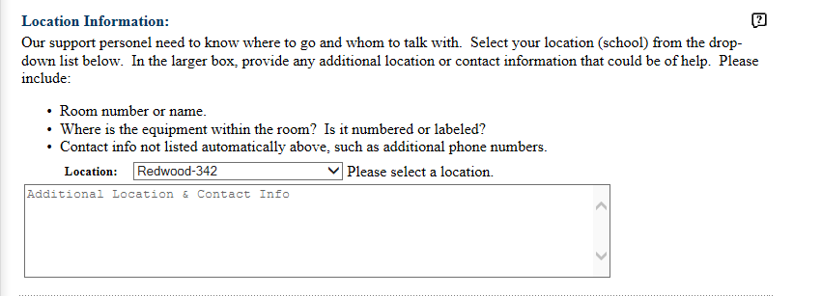

- Describe the issue in the Work Request box.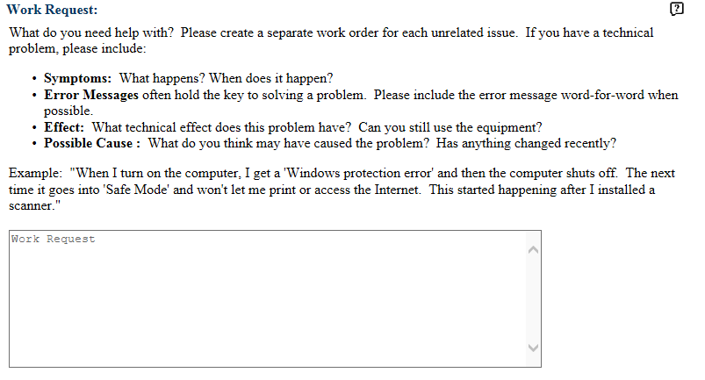

- You may write about the Impact and Urgency of the issue, but this is not required. You may also choose a Case Type from the list, but if you don’t know what to choose, you can leave this blank.

- Click “Submit.”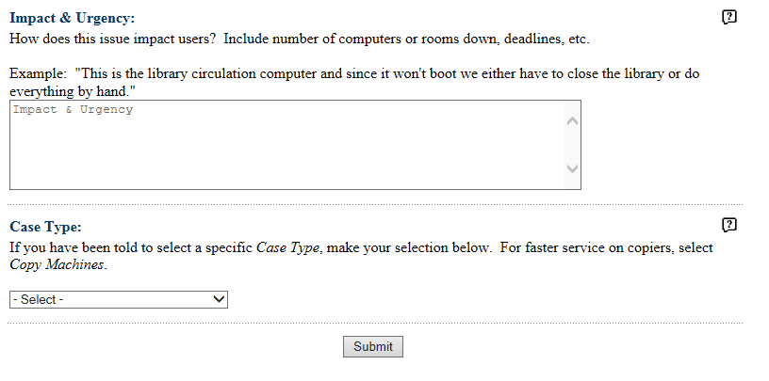

- Congratulations! You’re done!

