Submitting a Technology Work Order

- You will find a link to “Technology Work Order” in the Quick Links on the GSD Intranet Page, or in the GSD Portal under “District Resources.”

- Log in with your GSD Username and Password

- Click “Submit New Case”
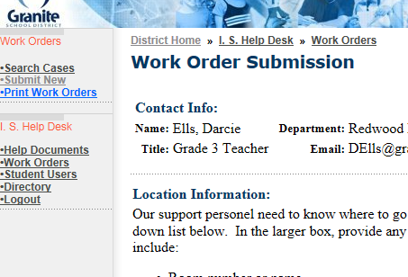

- Enter Location Information – Make sure the Location Box shows “Redwood-342” selected. Please also note your room number.

- Describe the issue in the Work Request box.

- You may write about the Impact of the issue, but this is not required. You may also choose a Case Type from the list, but if you don’t know what to choose, you can leave this blank.
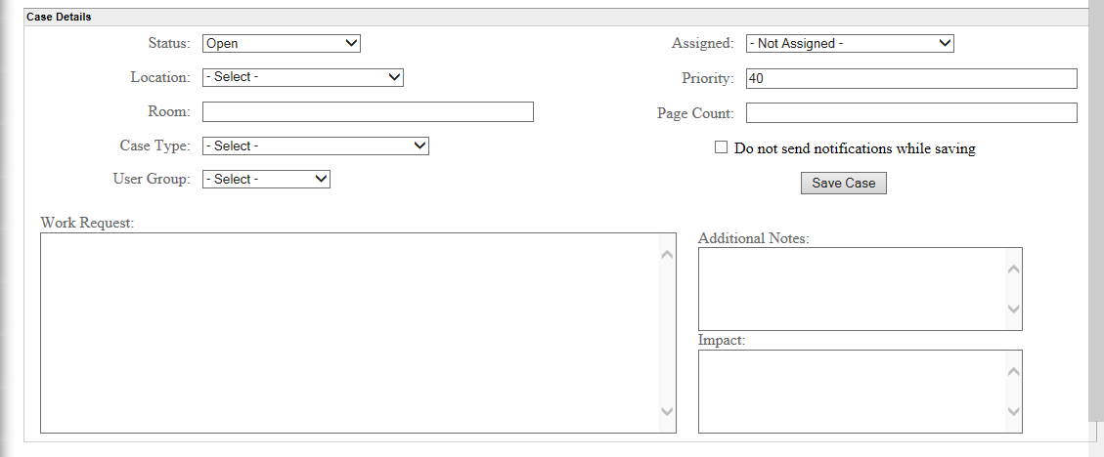

- Click “Save.”

- Congratulations! You’re done!

